**Lab practical 06**

**COA**

**Question:**

**Write a program in assembly language to display a two-digit number on the screen. The**

**two-digits number is required to be taken in the program itself.**

**Code:**

**ORG 100h**

**; Two-digit number to be displayed (let's say 57)**

**MOV AL, 58d ; Load the two-digit number into AL**

**; Split the number into tens and units**

**MOV BL, 10 ; Set divisor to 10 to separate tens and units**

**DIV BL ; Divide AL by 10, AL = quotient (tens), AH = remainder (units)**

**; Store the quotient (tens) and remainder (units)**

**MOV BH, AL ; Store the tens digit in BH**

**MOV BL, AH ; Store the units digit in BL**

**MOV DX, OFFSET msg_1**

**MOV AH, 09h**

**INT 21h**

**; Convert tens digit to ASCII**

**ADD BH, '0' ; Convert the tens digit to ASCII**

**MOV DL, BH ; Move the ASCII tens digit to DL for printing**

**MOV AH, 02h ; DOS interrupt to print a character**

**INT 21h ; Print the tens digit**

**; Convert units digit to ASCII**

**ADD BL, '0' ; Convert the units digit to ASCII**

**MOV DL, BL ; Move the ASCII units digit to DL for printing**

**MOV AH, 02h ; DOS interrupt to print a character**

**INT 21h ; Print the units digit**

**; Terminate the program**

**MOV AH, 4Ch ; DOS interrupt to exit the program**

**INT 21h**

**msg_1 DB 'The two digit no is : $'**

**END**

**OUTPUT:**

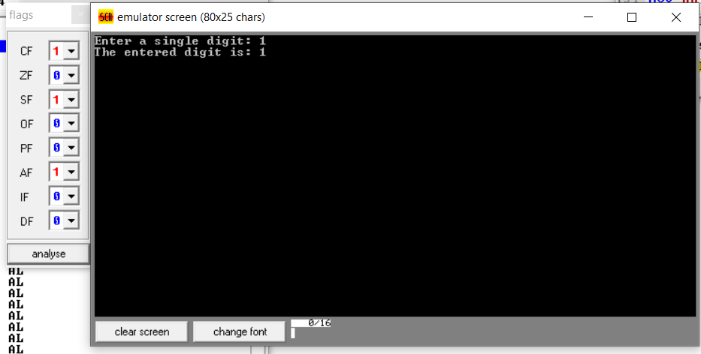

**2.** **Write an assembly language program to take two single-digit integers from the user and**

**print the result of addition on the screen.**

**CODE:**

**ORG 100h**

**; Display the message "Enter the first digit: "**

**MOV DX, OFFSET msg_input1**

**MOV AH, 09h**

**INT 21h**

**; Read the first digit from the user**

**MOV AH, 01h**

**INT 21h**

**SUB AL, '0' ; Convert ASCII to integer**

**MOV BL, AL ; Store the first digit in BL**

**; Display the message "Enter the second digit: "**

**MOV DX, OFFSET msg_input2**

**MOV AH, 09h**

**INT 21h**

**; Read the second digit from the user**

**MOV AH, 01h**

**INT 21h**

**SUB AL, '0' ; Convert ASCII to integer**

**MOV CL, AL ; Store the second digit in CL**

**; Perform addition**

**ADD BL, CL ; Add the two digits, result in BL**

**; Convert the result back to ASCII**

**ADD BL, '0' ; Convert the sum to ASCII**

**; Display the message "The result of addition is: "**

**MOV DX, OFFSET msg_output**

**MOV AH, 09h**

**INT 21h**

**; Print the result**

**MOV DL, BL**

**MOV AH, 02h**

**INT 21h**

**; Print a new line (CRLF)**

**MOV DL, 0Dh**

**MOV AH, 02h**

**INT 21h**

**MOV DL, 0Ah**

**INT 21h**

**; Terminate the program**

**MOV AH, 4Ch**

**INT 21h**

**; Data section with messages**

**msg_input1 DB 'Enter the first digit: $'**

**msg_input2 DB 0Dh, 0Ah, 'Enter the second digit: $'**

**msg_output DB 0Dh, 0Ah, 'The result of addition is: $'**

**END**

**OUTPUT:**

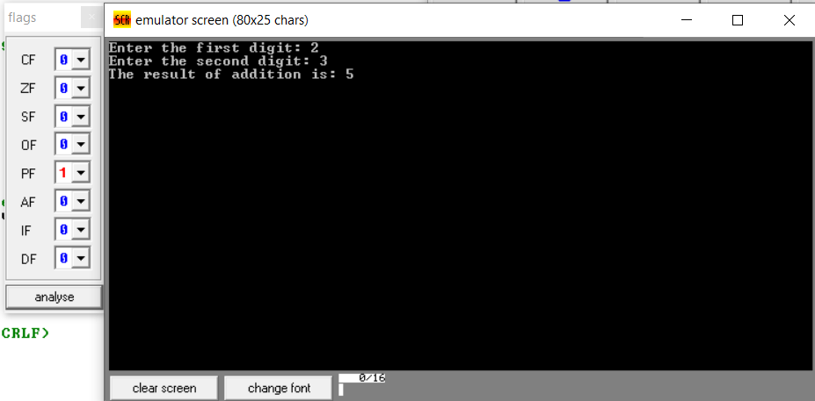

**GITHUB:**

[**https://github.com/srijachakilam15/COA/blob/main/lab%20practical%2003.docx**](https://github.com/srijachakilam15/COA/blob/main/lab%20practical%2003.docx)

s